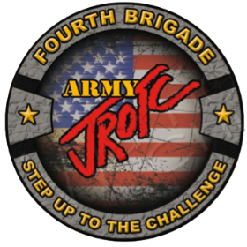 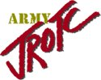

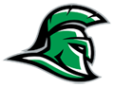

**WEST Brunswick HS**

**ARMY JROTC**

**PROMOTION**

**Study Guide**

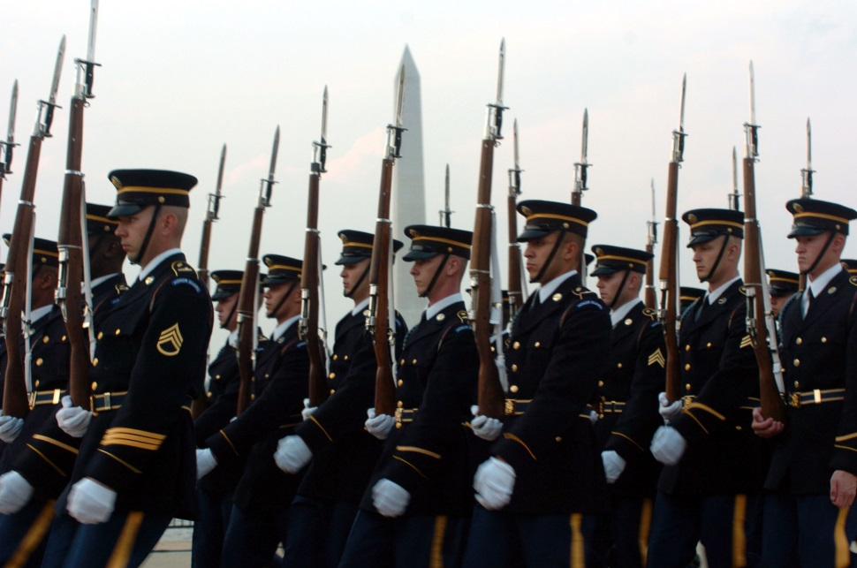

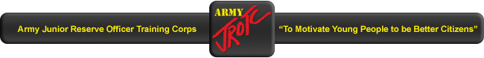

**THE JUNIOR ROTC CADET CREED**

I am an Army Junior ROTC cadet.

I will always conduct myself to bring credit to my family, country, school and the Corps of cadets.

I am loyal and patriotic.

I am the future of the United States of America.

I do not lie, cheat or steal and will always be accountable for my actions and deeds.

I will always practice good citizenship and patriotism.

I will work hard to improve my mind and strengthen my body.

I will seek the mantle of leadership and stand prepared to uphold the Constitution and the American way of life.

May God grant me the strength to always live by this creed.

**1ST General Order**

I will guard everything within the limits of my post and quit my post only when properly relieved

Alpha, Bravo, Charlie, Delta, Echo, Foxtrot, Golf, Hotel, India, Juliet, Kilo, Lima, Mike, November, Oscar, Papa, Quebec, Romeo, Sierra, Tango, Uniform, Victor, Whiskey, X-ray, Yankee, and Zulu

***Phonetic Alphabet******:***

**2nd General Order**

I will obey my special orders and perform all my duties in a military manner

**3rd General Order**

I will report violations of my special orders, emergencies, and

anything not covered in my instructions to the commander of relief

**Chain of Command**

* + Commander and Chief President Joe Biden
  + Secretary of Defense Honorable Lloyd Austin

# Sec of Army Honorable Christine Wormuth

# Chairman of the Joint Chiefs GEN Mark Miley

# Of Staff

* + Army Chief of Staff GEN James C. McConville
  + TRADOC Commander GEN Paul E. Funk II
  + Cadet Command Commander MG Johnny Davis (*CSM Kenneth J Craus*)
  + 4th BDE Commander COL Trevor W. Hill (*CSM Aron Spahl*)
    - ***Sergeant Major of the Army*** SMA Michael A. Grinston
      * + ***(Parts of the Chain of Command may change)***

**General Knowledge**

What is the mission of JROTC?

* To motivate young people to be better citizens

What is the key to success in JROTC?

* The key to success in JROTC is teamwork

What does LET stand for?

* Leadership, Education, and Training

What does “JCLC” stand for?

* Junior Cadet Leadership Challenge

What is your winning color: explain why?

* + Brown – Builder
  + Green – Planner
  + Red – Adventurer
  + Blue – Relater
* *(Example)*My winning color is brown which means I am a builder, and this means that my interests show that I am a hand on character.

Who created JROTC, where, and under what act?

* Captain Alden Partridge in Norwich Vermont at the American Literary, Scientific, and Military academy.
* The National Defense Act of 1916

What is the name of the Army Song?

* The Army Goes Rolling Along.

What is the Army Motto?

* This We’ll Defend

What day is the Army’s birthday?

* June 14th 1775

Who is the vice president?

* Mike Pence

What are the three branches of government?

* Executive, Legislative, Judicial

Name the 3 components of the U.S. Army

* Active Army, Reserves, and Department of civilian work force

What major Command does JROTC fall under?

* US Army Cadet Command

How many Brigades is Cadet Command comprised of?

* 8

What Brigade do you belong to?

* 4th BDE JROTC

When did the Continental Congress in Philadelphia create the 1st Stars and Strips flag?

* June 14th, 1777

Who wrote our National Anthem?

* Francis Scott Key

When did Francis Scott Key write our National Anthem?

* The War of 1812

What is the name of the “National March”?

* The Stars and Stripes Forever

Who wrote our National March?

* John Phillip Souza

Who made our first flag?

* Betsy Ross

When was D-Day

* June 6, 1944

When was the Pearl Harbor attack?

* December 7, 1941

How many Supreme Court judges are there? 9

How many people in the House of Representatives? 435

What is the serial number of your rifle?

What is the nomenclature of your weapon?

This is an M1903 A3 Springfield rifle, it is a single shot bolt action, manually operated, magazine fed, .30 caliber weapon weighing 8.7 pounds, and is 43 inches long. Its four line groove barrel has an effective range of 540 yards. It is equipped with a front blade sight and a rear aperture sight, when bayonet is affixed to the end it increases the weapon's length to 59 inches

**Leadership**

What is the definition of leadership?

* The ability to influence others to accomplish a mission in the manner desired, by providing direction, purpose, and motivation.

What is the definition of a subordinate?

* A person of lower rank/grade

What are the rank titles of noncommissioned officers?

* CPL, SGT, SSG, SFC, 1SG/MSG, SGM/CSM/SMA

What are the rank titles of commissioned officers?

* 2LT, 1LT, CPT, MAJ, LTC, COL, BG, MG, LTG, GEN, GEN of the Army

What positions make up the battalion staff?

* S-1 Adjutant – Personnel Actions
* S-2 Information/Security
* S-3 Operations
* S-4 Logistics
* S-5 Special Projects

What are the 3 parts of the “Pyramid of Authority”?

* Chain of Command – Guarantees all members are on the same team
* Span of Control – The immediate subordinate’s one leader can effectively control
* Unity of Command – Only one commander

Who is a private’s first line supervisor?

* Squad leader

What are the 7 Army values?

* Loyalty Integrity
* Duty Personal Courage
* Respect
* Selfless-Service
* Honor

What are the 3 leadership styles? Can you give examples?

* + Directing – One way conversation from the leader, subordinates have little knowledge, time is a factor
  + Participating – Leader solicits ideas, subordinates have some knowledge, time is not a factor
  + Delegating – leader delegates authority, subordinates have experience and knowledge, time may or may not be a factor

**First Aid**

What is the definition of first aid?

* The immediate care given to an injured or ill individual to keep him or her alive or stop further damage until help arrives.

What are the three types of bleeding?

* Arterial
* Venous
* Capillary

What is a tourniquet? What type of bleeding was it used for? Who can remove a tourniquet?

* Tourniquet- a device for stopping the flow of blood through a vein or artery, typically by compressing a limb with a cord or tight bandage.
* It is used for Arterial bleeding
* The person who can remove the tourniquet is the Medical professional

What are the three types of heat injuries?

* Heat cramps
* Heat Exhaustion
* Heatstroke

Name /Explain some types of burns

* 1st degree burn - mild compared to other burns. They result in pain and reddening of the epidermis
* 2nd degree burn - Second-degree burns (partial thickness burns) affect the epidermis and the dermis (lower layer of skin). They cause pain, redness, swelling, and blistering.
* 3rd degree burn - severe burn characterized by destruction of the skin through the depth of the dermis and possibly into underlying tissues, loss of fluid, and sometimes shock.

What are the 4 lifesaving steps?

* Clear the Airway, stop the bleeding, treat for shock, and bandage the wound.

What is the Heimlich maneuver used for?

* To clear a blocked airway

What is mouth to mouth used for?

* To restore breathing

What do the letters “CPR” stand for and what is it used for?

* Cardiopulmonary resuscitation; to restore the heart beat and breathing to a patient

What does the acronym R.I.C.E. represent?

* R = Rest C = Compression
* I = Ice E = Elevation

In CPR, approximately how many compression per minute?

* 100

In CPR, what is the ratio for compressions/rescue breathing?

* 30 compressions - 2 recue breaths

In CPR, how far should you compress the chest area?

* 2 inches

**Flags**

What are the types and sizes of the flags?

* Garrison- 20’x 38’
* Post- 10’ x 19’
* Storm- 5’ x 9 ½’

How should you raise and lower the Flag?

* Raise it briskly and lower it ceremonially.

How do you raise the flag to half-staff?

* Raise it briskly to its peak and then lower it ceremonially to half-staff

What do the colors of the flag represent?

* White: Hope, purity, and innocence
* Red: Hardiness and valor
* Blue: reverence to God, loyalty, vigilance, perseverance, and justice

Why would a flag be flown upside down?

* A sign of distress

**Uniform**

What is a Gig line?

* Is when the shirt is in line with the belt buckle and the zipper seam of the pants

How do you wear the cord on your uniform? What does it represent?

* You wear it on your left shoulder depending on what cord it is. It represents what team you are on

What angle should your feet be at in the position of attention?

* 45 degree angle

How are the different items worn on your ASU?

* + Beret
  + Name plate
  + Ribbons/awards

**PT**

What is meant by the FITT factors?

* Frequency, intensity, time, and type

What 3 exercises are on the Army physical fitness test?

* Push-ups, sit-ups, and the 2-mile run

What are the 3 phases of fitness conditioning?

* Preparatory, conditioning, and maintenance

What are the events in Cadet Challenge?

* Curl-ups, pull-ups, v-sit reach, shuttle run, and 1-mile run/walk

**Maps**

What is the definition of a map?

* A portion of the Earth’s surface as seen from above and drawn to scale.

What are the 5 colors of a map and what do they represent?

* Red = Man-made objects (IE: Roads)
* Black = Man-made objects (IE: Buildings)
* Blue = Wet lands/water
* Brown = Elevation
* Green = Vegetation

What is the general rule for reading a map?

* You read it right and up.

How many degrees on a compass/protractor?

* 360

What are the three North’s of map reading?

* True North, Magnetic North, and Grid North

On a topographical map where do you go to understand a symbol?

* Legend

How close do the following grid coordinates get you to a location:

* 4 digits =1000m
* 6 digits =100m
* 8 digits =10m
* 10 digits = 1m

On a topographical map what do we use to measure distance?

* The bar scale

What is a GM angle?

* The difference between grid and magnet azimuths

Name the 5 major terrain features are as discussed in class?

* Hill
* Ridge
* Depression
* Valley
* Saddle

What is a grid zone designator?

* It is 2 letters that precede the grid coordinates and tells you which portion of the map to look at.

If you find a marking on your map and you do not know what it is where should you look?

* Legend

What is the size of a grid square?

* 1000m X 1000m

What is an azimuth?

* A direction

*END OF GUIDE*