Important Contact Sources

1. Remind

Join our Reminds!

Parents: https://www.remind.com/join/band28461

OR

Text the message, @band28461 to 81010

Students: <https://www.remind.com/join/pride>28461

OR

Text the message, @pride28461 to 81010

Everyone should join remind for short messaging that may involve reminders about important dates/times, etc. or info about changes due to weather, etc.

1. The BAND App

Add the app (It’s free!) and use it to communicate, post pictures, get announcements, and more OR you can access it using your computer!

You can use this code to join the group….

<https://band.us/n/a2a958beVanek>

OR use the QR code below…..

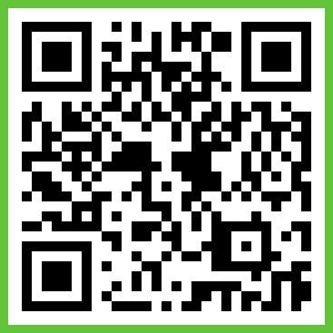

1. Google Classroom

(these codes will be changed once school starts & I will notify parents of the new code as needed)

Codes for Fall 2024 Classes…..

**Marching Band (Winds): ijwcv5h**

**Percussion: o4ktgbq**

**Color Guard: 6iypnsz**

1. Contact info for Mr. Palmer

School phone: 910-756-6880 ext. 12081

Email: [mpalmer@bcswan.net](mailto:mpalmer@bcswan.net)

Easiest way to reach and contact is via email or during school “office hours,” which are scheduled for 3rd block. Times are still TBD.

1. School website

<https://www.bcswan.net/Domain/18>

* Click on Departments
* Click on Fine Arts
* Click on Mr. Palmer’s name
  + Includes a calendar (always under construction)
  + Includes forms and files
  + Includes helpful links